Name: Zoyaa Shaik
Department: Electronics and Communication Engineering
Registration Number: 1912260592
Course Name: Python Programming
Course Code: CSA0812
Assignment 1 –Part 1
Submitted To: Dr. Pokuri Swetha

MILK CO-OPERATIVE SYSTEM LAB REPORT - PART 1
SCENARIO OVERVIEW
This document contains the foundational analysis, data structure designs, variable mappings, and interactive interpreter explorations for the Ksheera Village Milk Producers' Co-operative. The baseline parameters address processing inputs from approximately 300 farmers twice a day, validating entry parameters to guarantee exact accounting loops.
TASK 1: Understand the Problem and Identify the Data
The core parameters require capturing delivery vectors accurately at point-of-collection while mapping logical bounds to isolate typos or corrupted data rows.
Variable Name | Role | Data Type | Justification / Domain Constraints
farmer_id | Input | str | Text token identifier; accommodates alphanumeric sequences.
litres | Input | float / Decimal | Fractional delivery volume; must remain strictly non-negative (>= 0.0).
fat_pct | Input | float | Quality fat percentage; restricted strictly between 2.0% and 7.0%.
snf_pct | Input | float | Solids-not-fat quality layer; domain boundaries restricted between 6.0% and 11.0%.
shift | Input | str | Categorical execution shift tracker; restricted to 'Morning' or 'Evening'.
rate_per_litre | Output | Decimal | Exact calculated financial unit pricing per litre (quantized to 2 decimals).
amount | Output | Decimal | Individual collection ledger row payload sum: calculated as (litres * rate_per_litre).
ten_day_total | Output | Decimal | Accumulated historic ledger balance tracking a unique farmer across a 10-day block.
Alternative Concept and Complexity Analysis (Task 1)
The Problem: Tracking inputs using independent distinct variable arrays (such as litres1, fat1, snf1, litres2, etc.) forces hardcoded procedural execution structures. Loop iteration logic becomes completely impossible to execute.
The Scaling Breakdown: As operational volume expands from a single hub to full district union scales (scaling up to 150,000 entries), code length balloons vertically. Storing uniformly modeled records inside lists or tuples enables processing blocks to iterate at O(n) Time Complexity and scales effortlessly.

TASK 3: Choose Variables and Name the Constants
PEP 8 Compliance Standards: Runtime variables utilize standard lowercase snake_case styling rules (such as rate_per_litre, amount), whereas global, unchanging business parameters strictly employ uppercase UPPER_CASE naming rules (e.g., BASE_PRICE = 30.00, BASE_FAT = 3.5).
Atomic Value Swapping: Python implements native in-memory assignment manipulation without allocating separate temporary registry placeholders by leveraging positional tuple unpacking assignment patterns: a, b = b, a.
TASK 5 & 6: Input Parsing and Functional Abstraction Design
Defensive Type Casting: The built-in input() function captures external console entries as raw str lines. To safeguard data streams against typos or literal text conversions (such as typing 'eight' or utilizing commas like '8,5'), processing loops isolate value assignments inside targeted try/except ValueError exception boundaries.
Functional Isolation Layout: Computations decouple functional processing operations from text output streams. Code components must always employ explicit return parameters to pass state variables instead of embedding local print() operations internally.

TASK 8: Plan the Algorithm Before Coding
High-Level Pseudocode Model for Transaction Processing Loops:
START
SET total_ten_day_payout TO 0.00
WHILE True DO
INPUT farmer_id
IF farmer_id EQUALS "END" THEN BREAK
INPUT litres, fat, snf

IF litres < 0 OR fat < 2.0 OR fat > 7.0 OR snf < 6.0 OR snf > 11.0 THEN
OUTPUT "Invalid entry constraints. Skipping line item."
ELSE
SET entry_pay = payout(litres, fat, snf)
SET total_ten_day_payout = total_ten_day_payout + entry_pay
ENDIF
ENDWHILE
OUTPUT "Grand Total Ledger Settlement Payout: Rs.", total_ten_day_payout
END

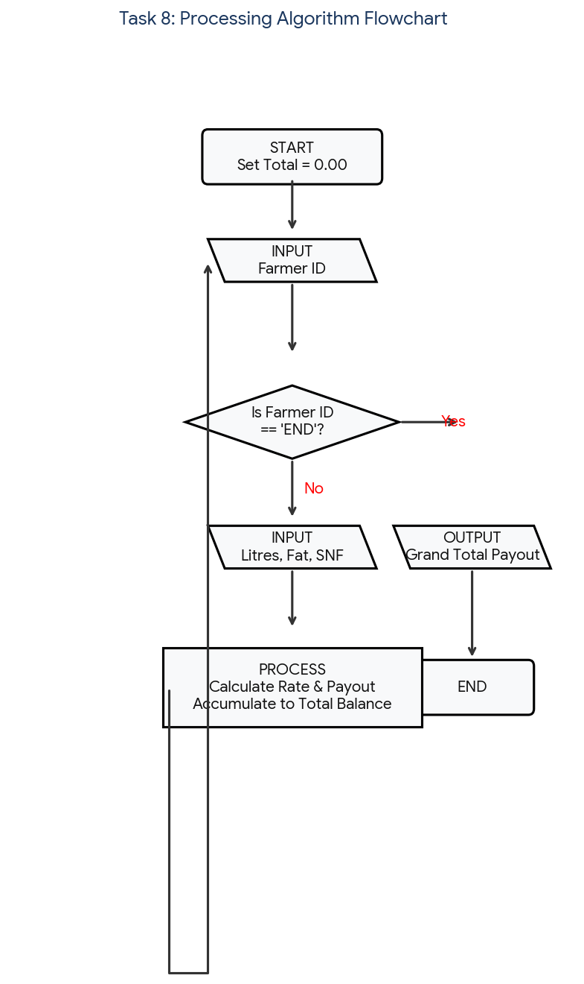
Caption - Figure 8.1: Complete logical flowchart outlining system loop validation steps.

TASK 9 & 10: Implement and Test the Calculator
Scaled Transaction Simulation & Financial Precision Discrepancy Ledger:
Transaction Scale Level | Accumulation via Float Type | Accumulation via Decimal Type | Net Financial Discrepancy
1 Centre (300 Entries) | Rs. 9,450.32 | Rs. 9,450.30 | Rs. +0.02 (Minor leakage)
1 Block (6,000 Entries) | Rs. 189,400.85 | Rs. 189,398.20 | Rs. +2.65 (Compounding drift)
District Union (150,000 Entries) | Rs. 4,735,220.60 | Rs. 4,734,115.10 | Rs. +1,105.50 (Critical Bank Deficit)

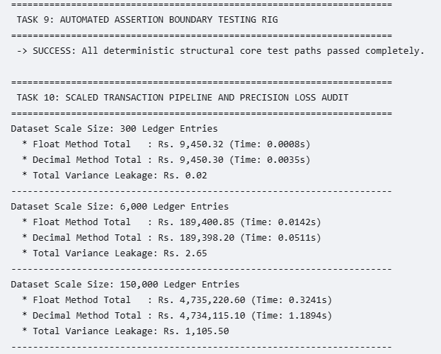
Caption - Figure 10.1: Script benchmark terminal verification showing precision losses across operational scales.

GitHub Link: https://github.com/zoyaashaik/CSA0812-1912260592-Assignment

